# Blue-Green environment

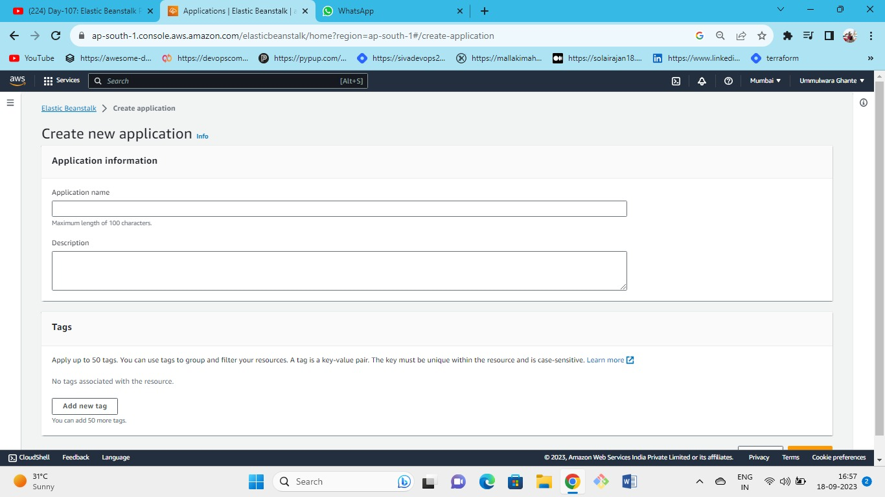



Open elastic beanstalk and create an application

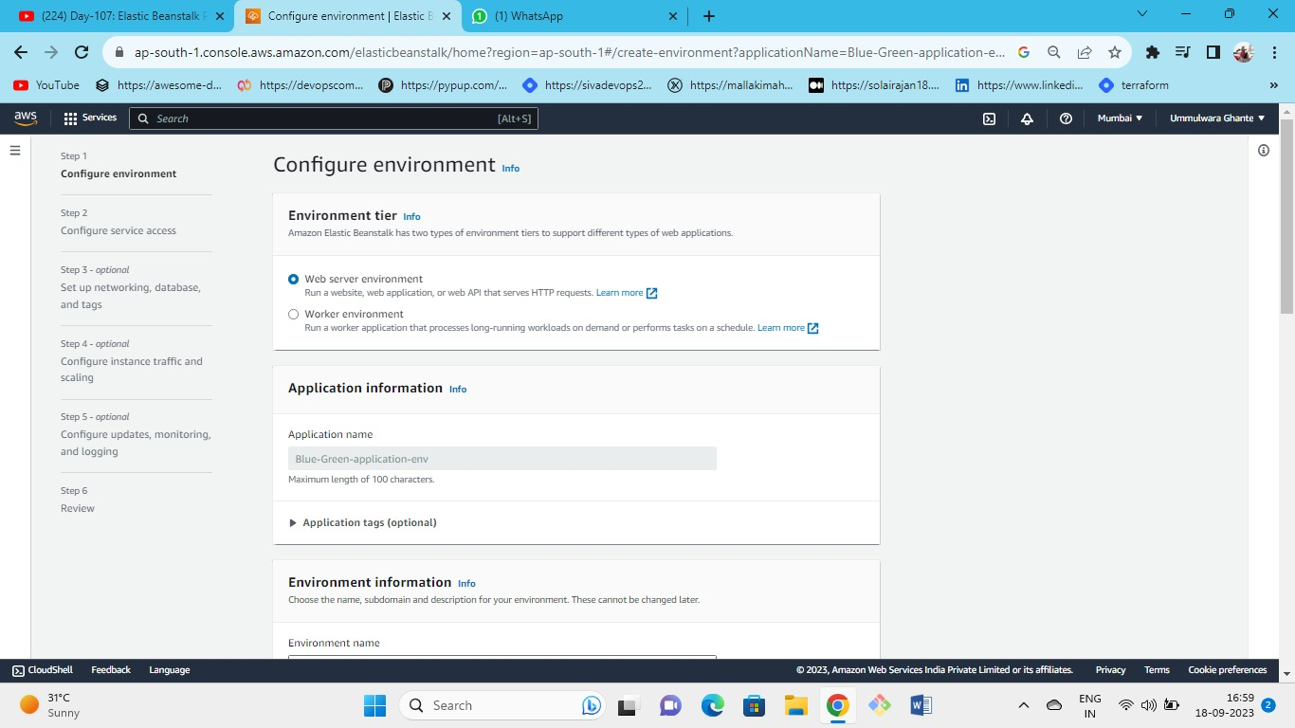



After creating an application create and configure an environment in that application.

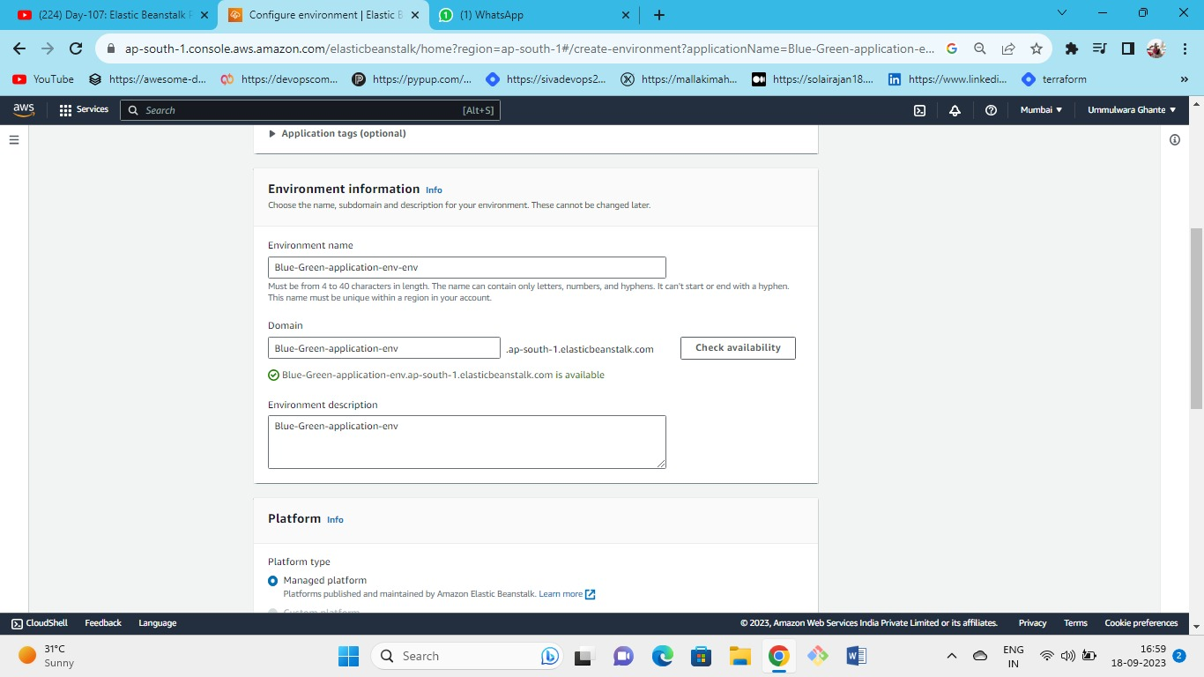



Give the environment domain name and check for availability.

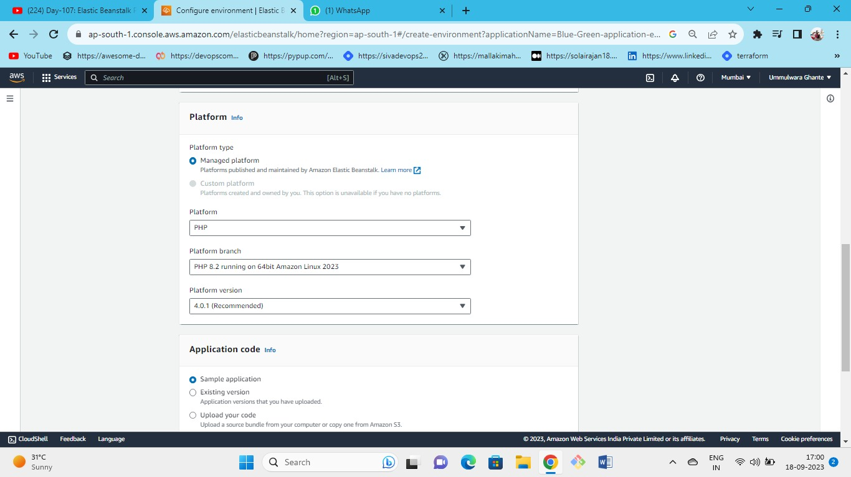



Select the managed platform type as PHP; for application code, choose sample application.

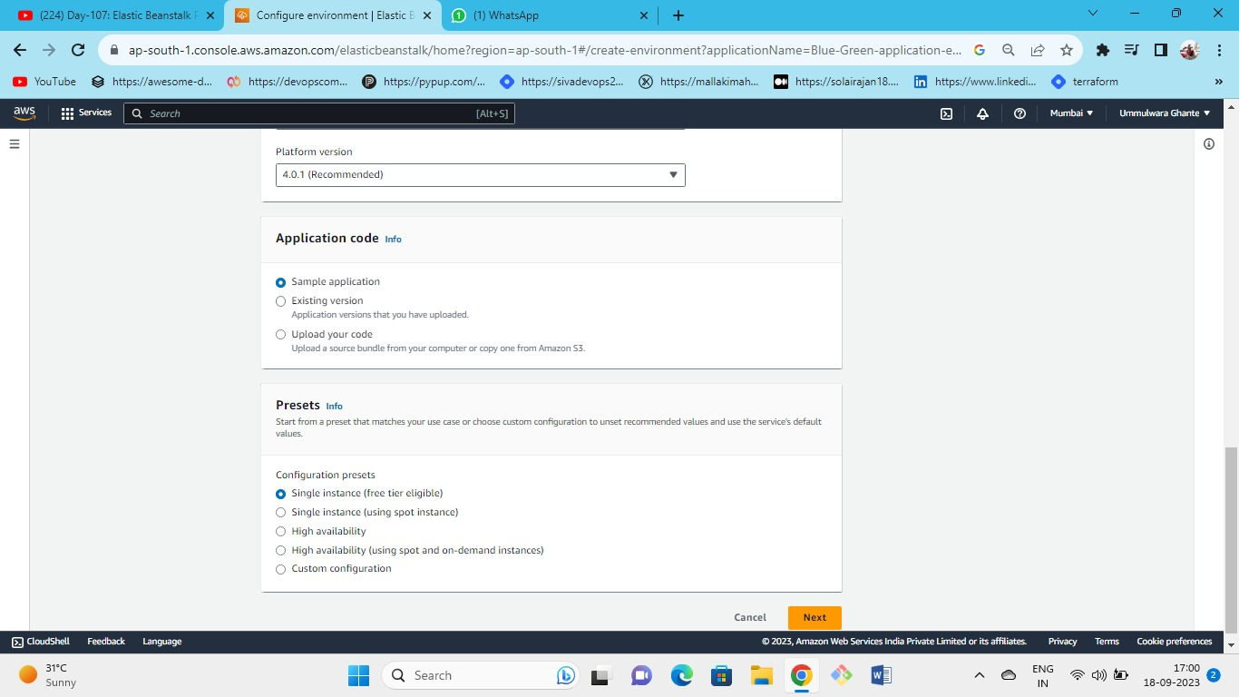



Choose presets as a single instance

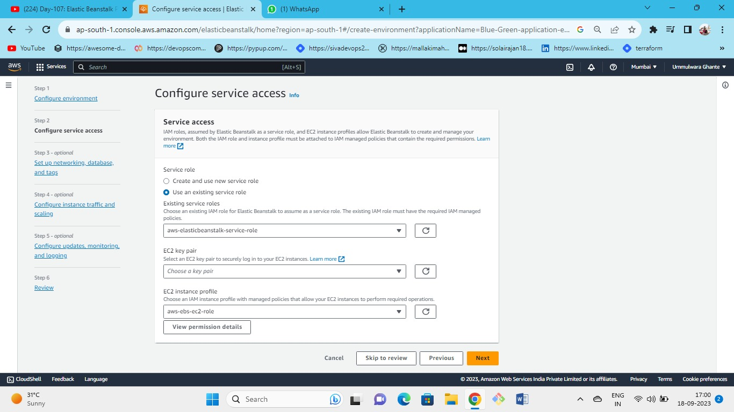



Select the roles of the instance profile and go next

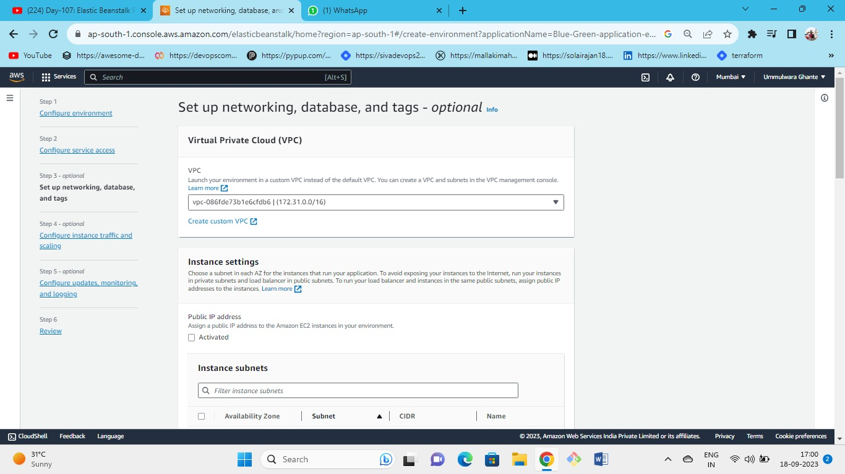



Keep VPC as default VPC

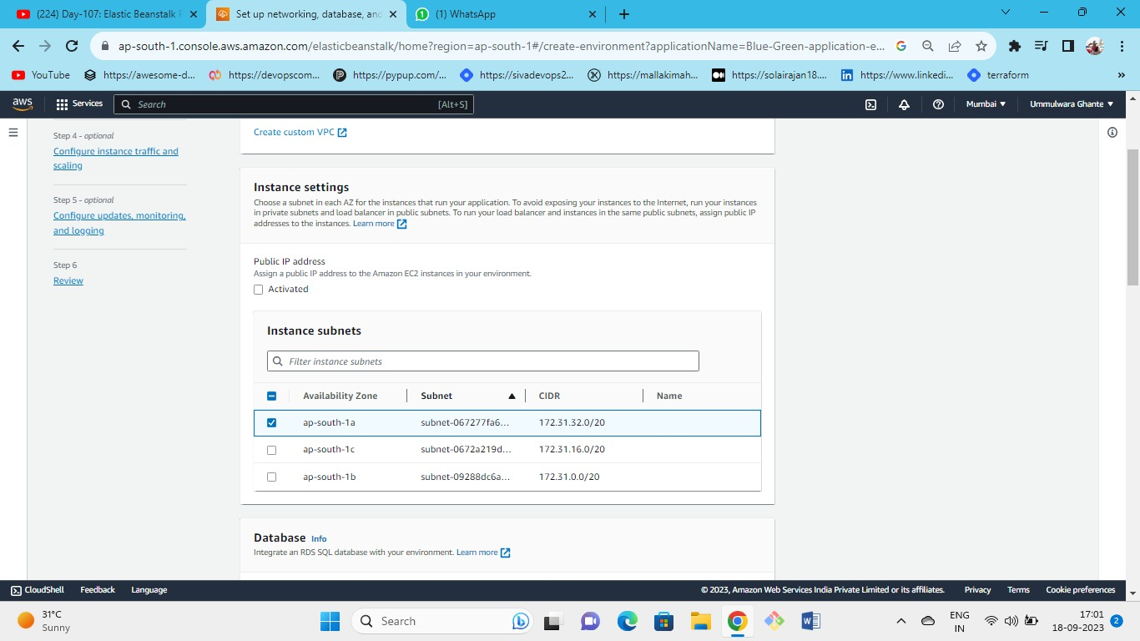Select the availability zone 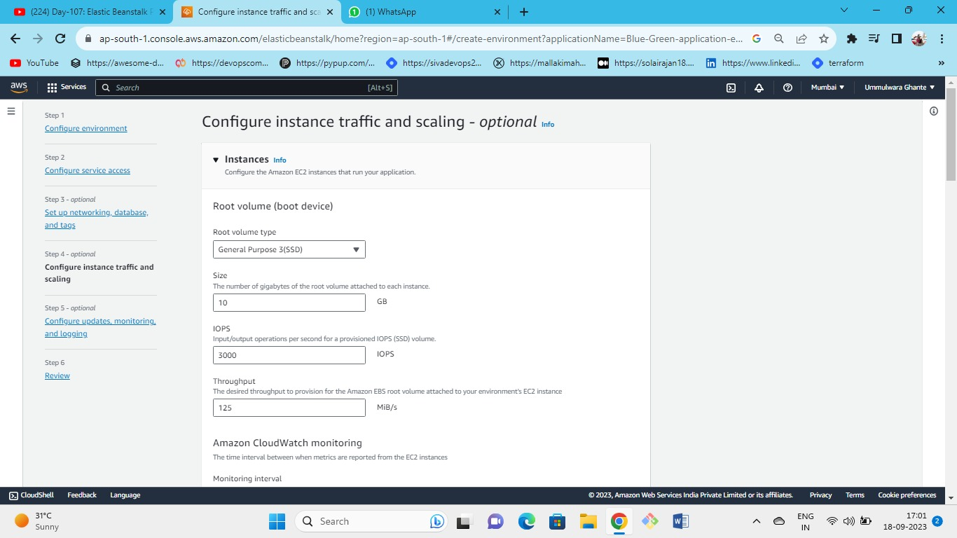



In step 4 choose root volume as ***general purpose 3 SSD*, and keep the remaining settings as default.**

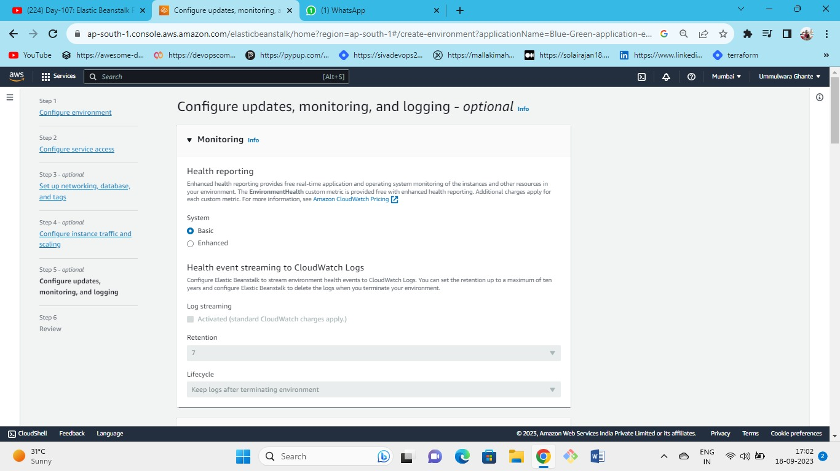



Keep health monitoring as Basic.

NOTE: CHANGE ONLY THE SETTINGS MENTIONED AND KEEP THE REMAINING SETTINGS AS DEFAULT.

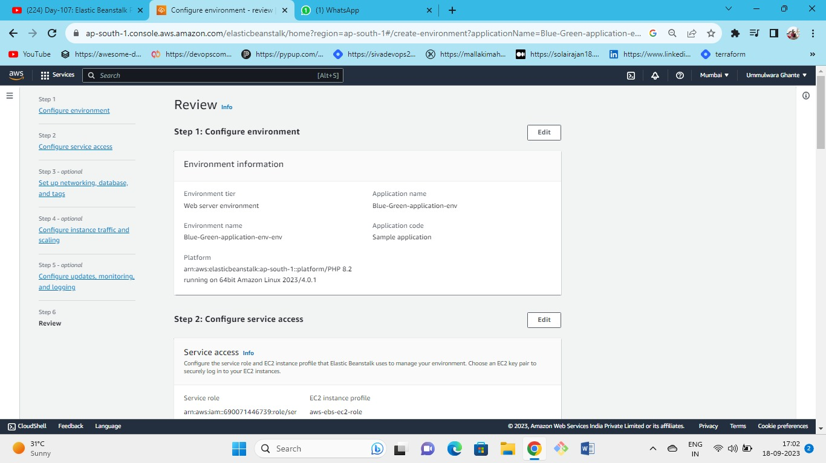



Review the steps and launch

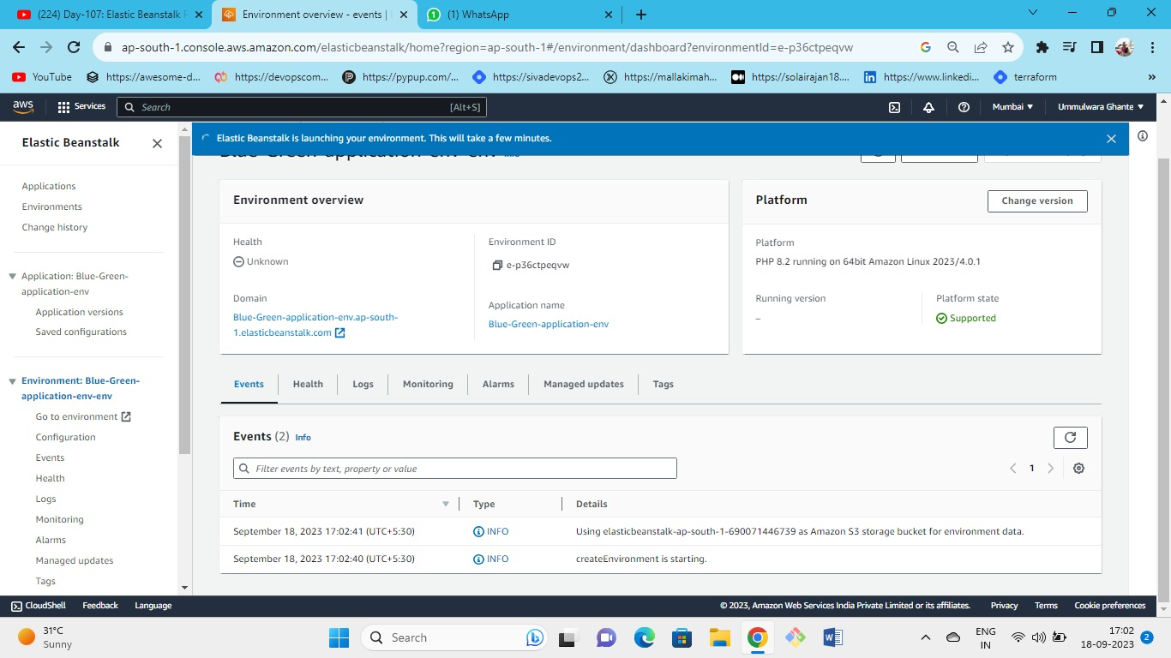hence our environment is launching.



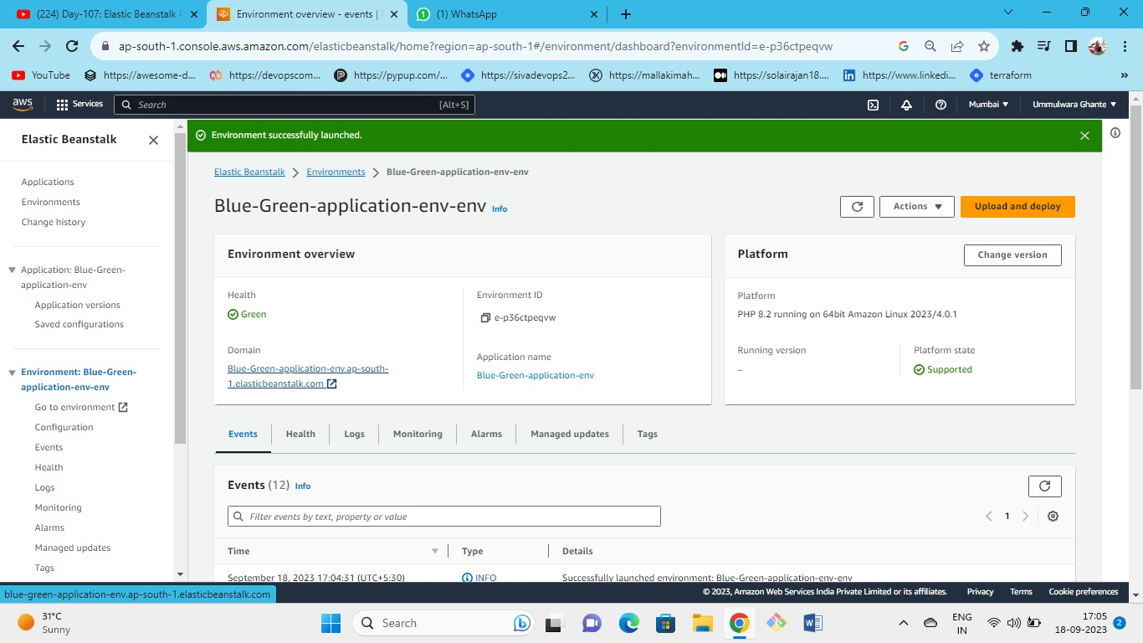



Our environment has been successfully launched and health status is also okay (green), Now click on the domain name URL to see the PHP sample application that has been created.

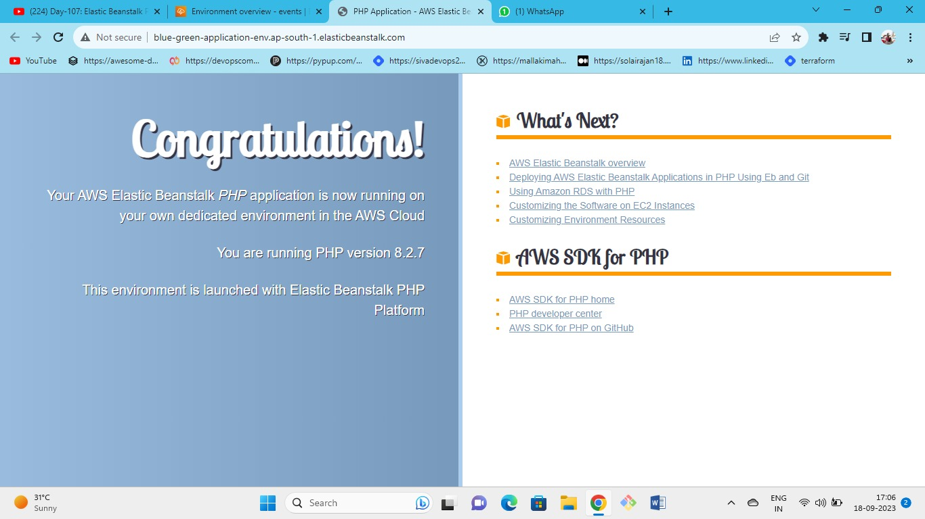

This is the sample application launched.

we can upload and deploy the version of PHP in a blue-green environment but cannot change the platform from PHP to a Python example.

As we cannot replace the PHP platform with Python, we need to create another environment (green-env).

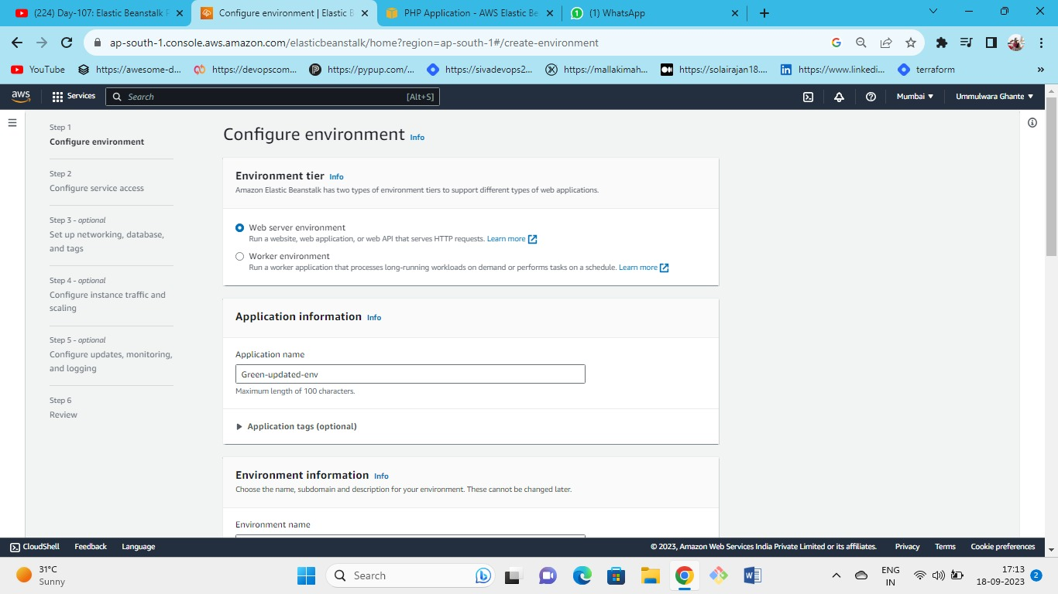



Go to the environment and create a new environment 🡪 green environment

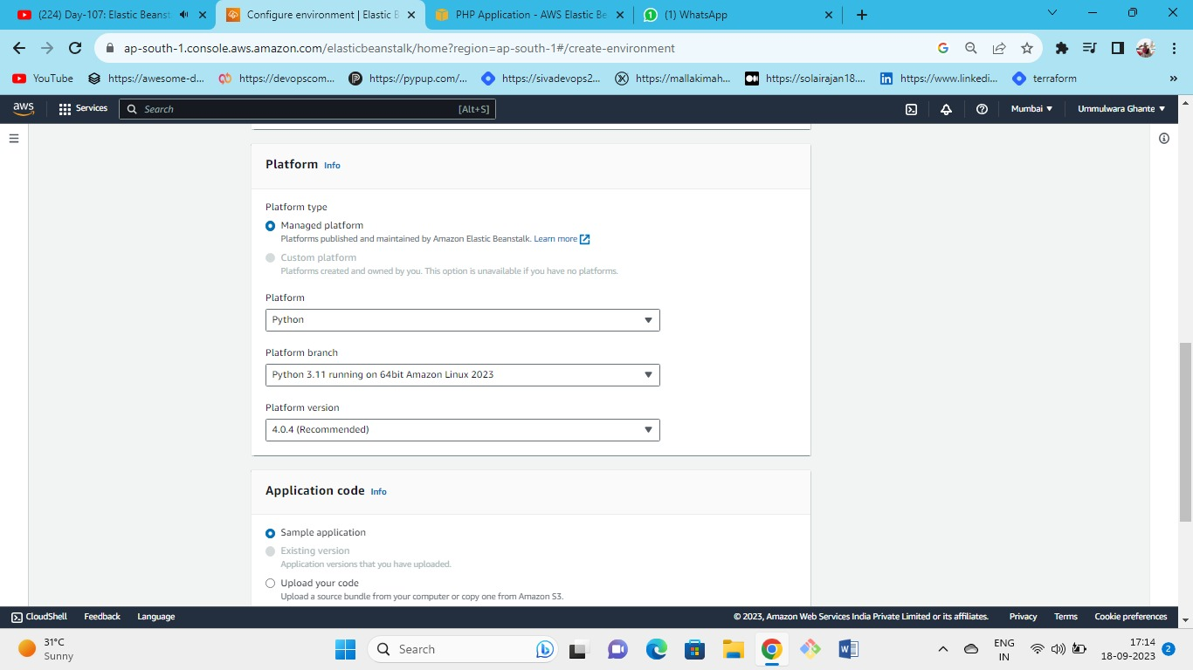



Choose managed platform as Python rest keep the default

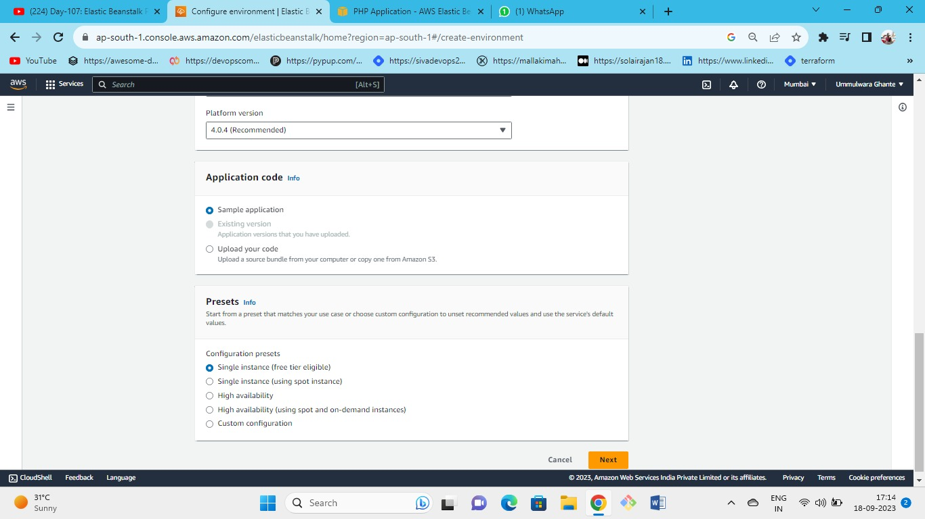



Select sample applications and presets as single instance

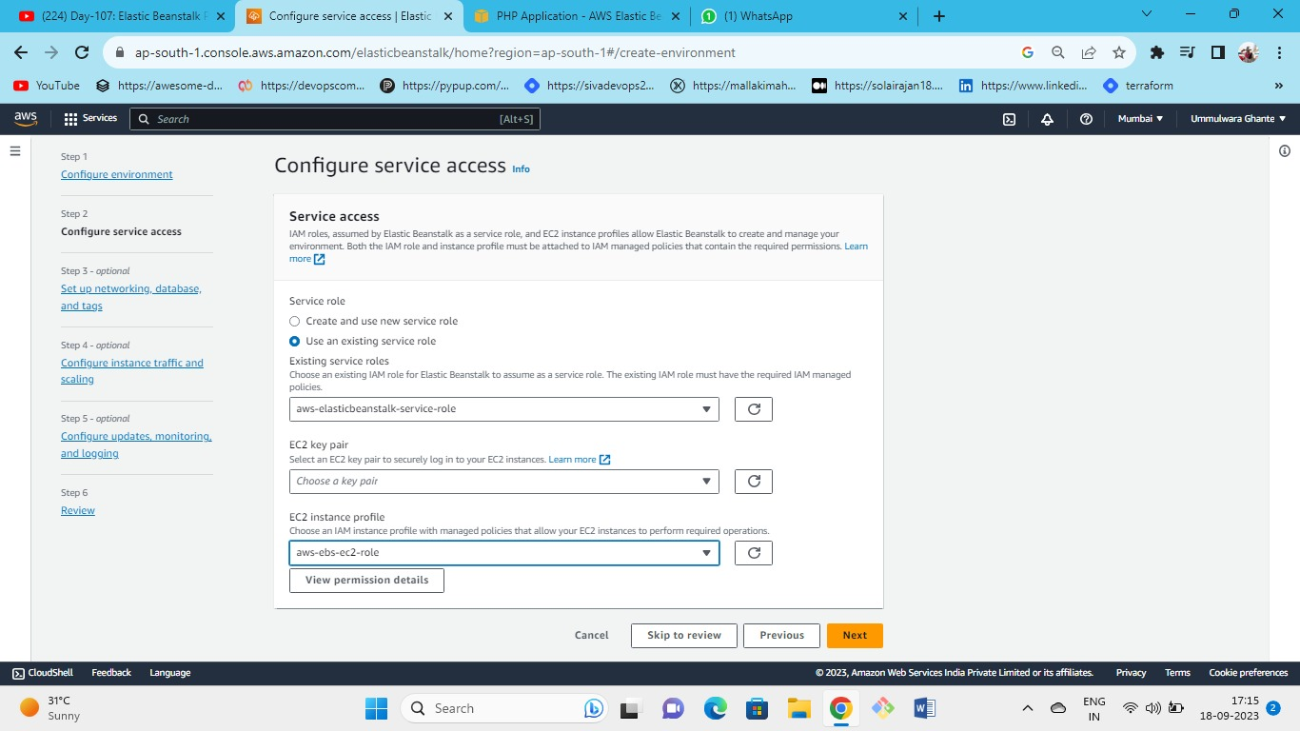

Select existing roles and select the instance profile roles

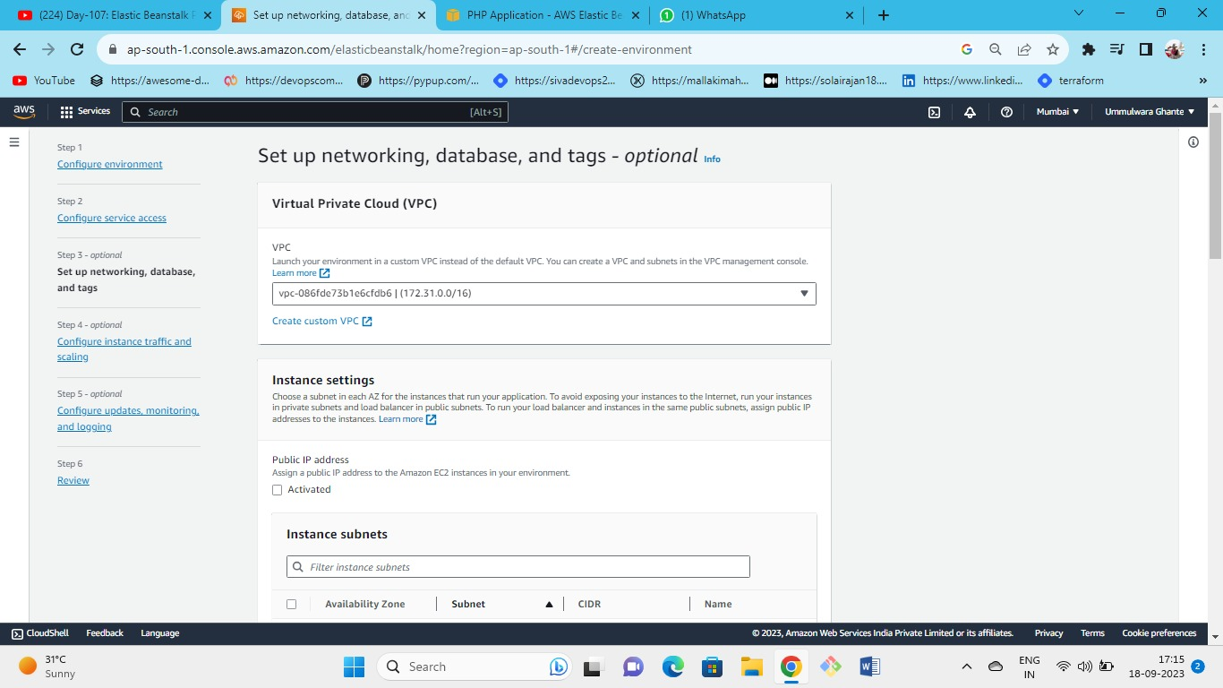



Keep VPC as default VPC

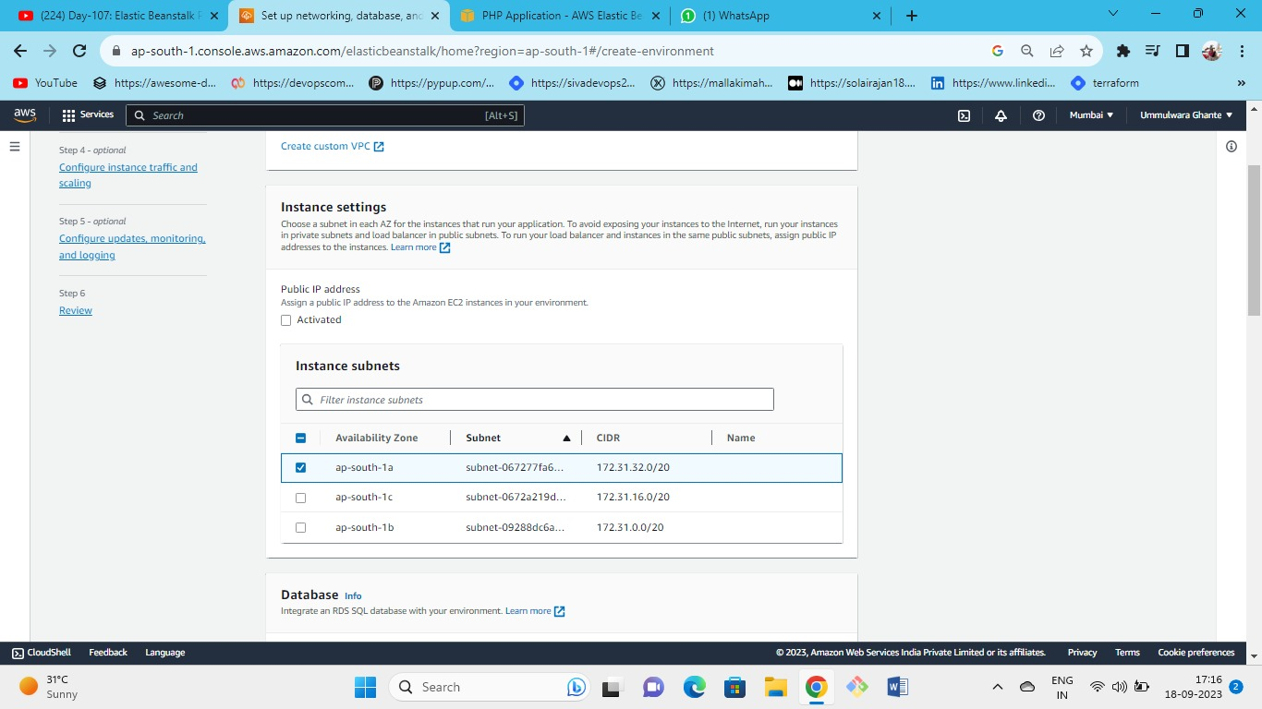

Select the availability zone for your instance

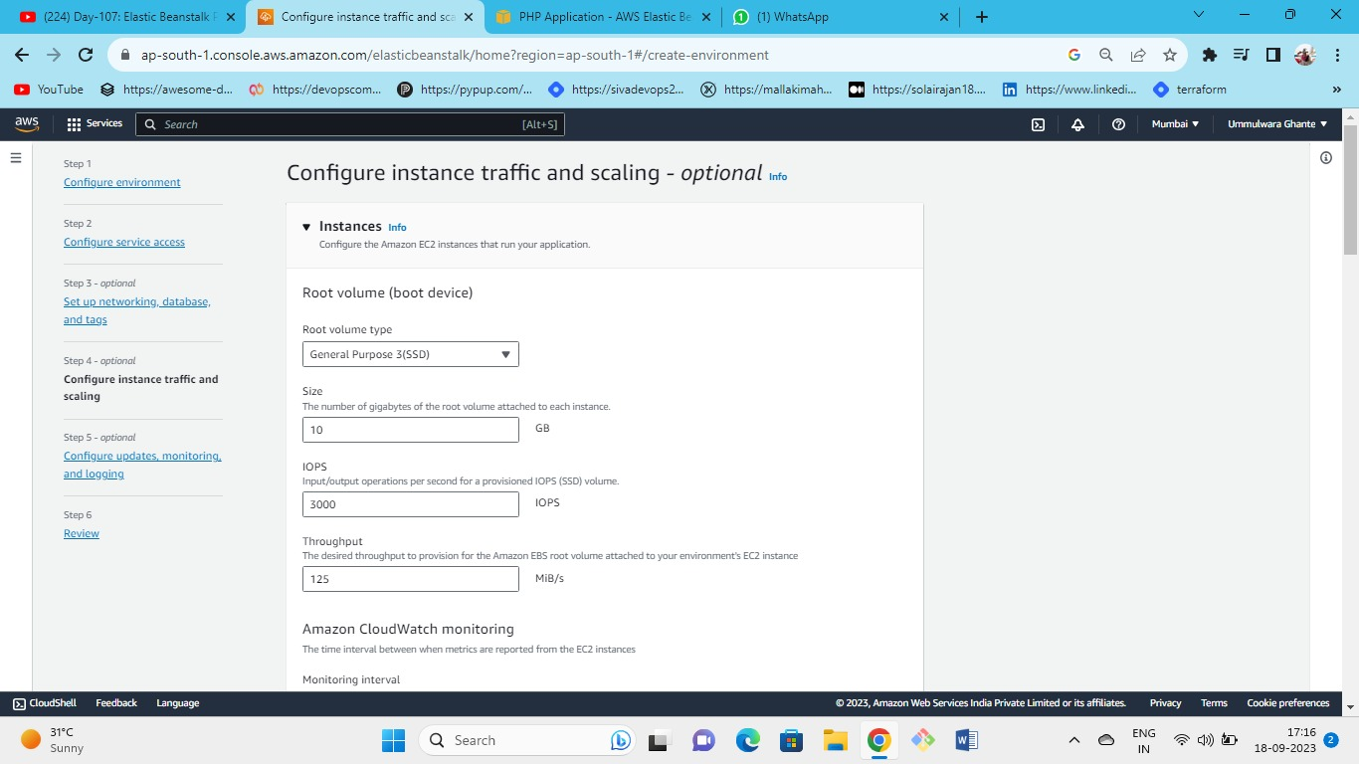

Choose root volume as general purpose SSD 3 and keep the rest settings default.

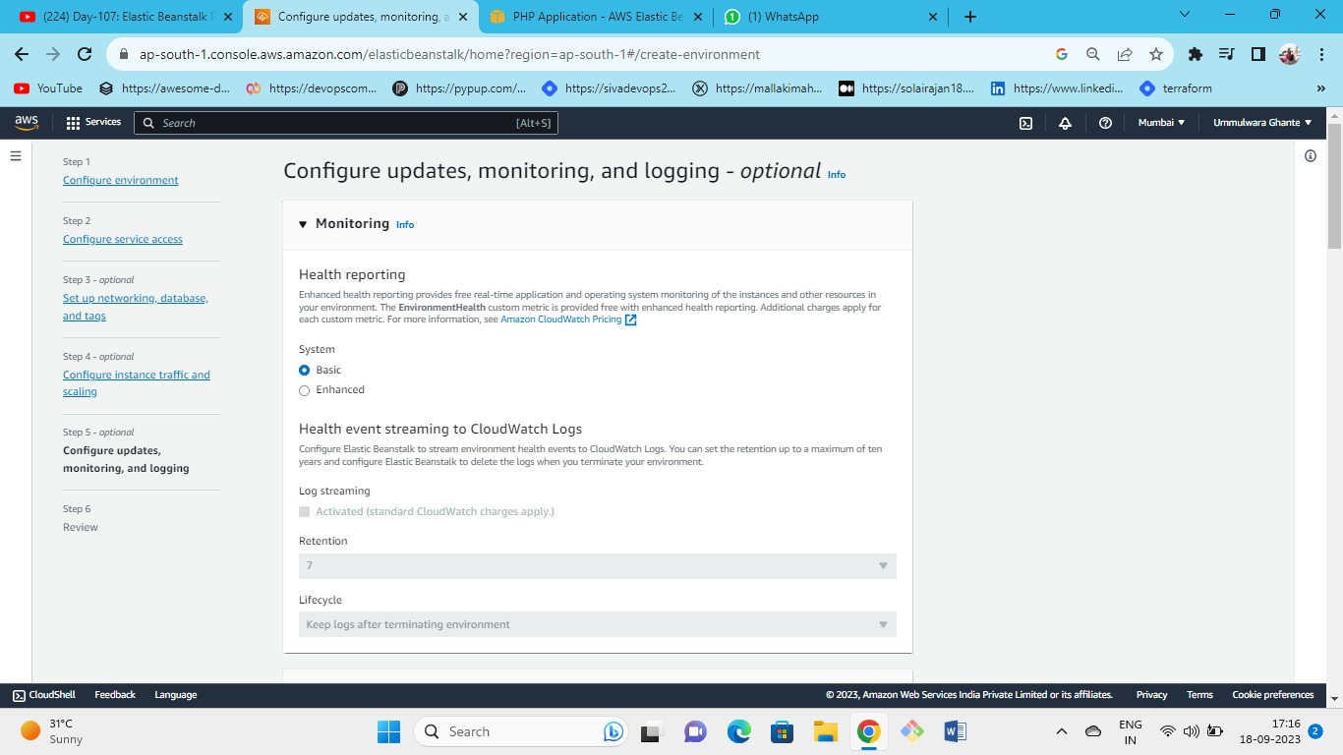



Keep the health monitoring as basic

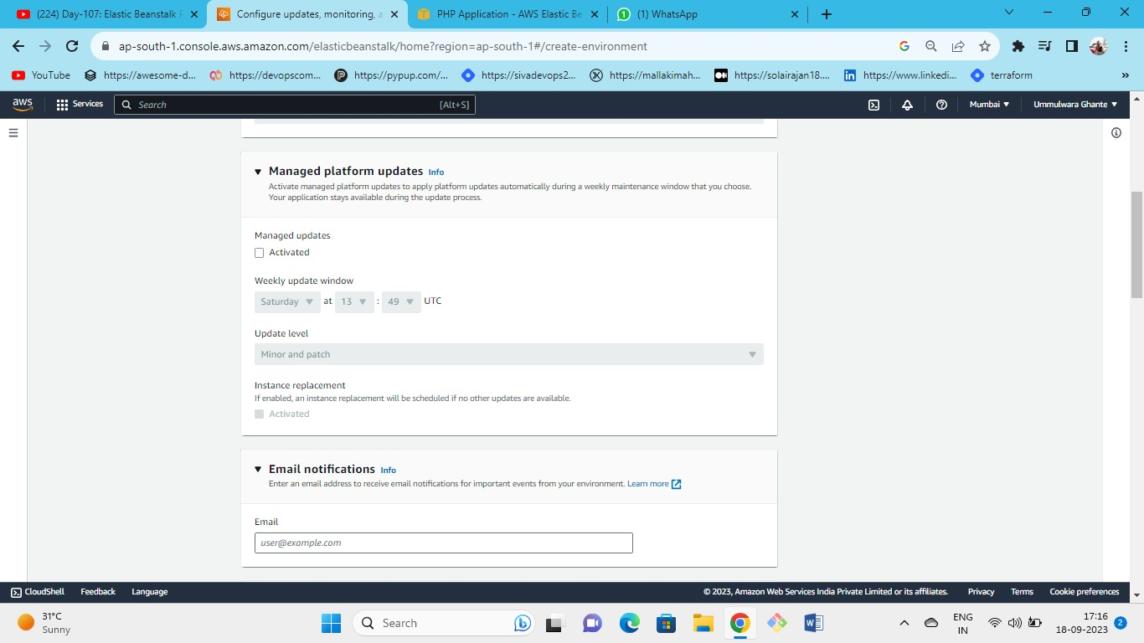



Here we are not activating managed updates so untick the checkbox

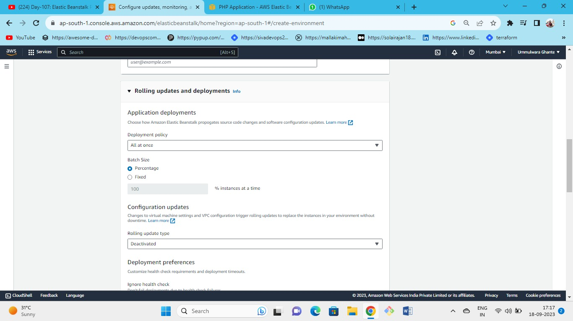



As this is single instance so the deployment policy will be all at once keeping the rest settings as default

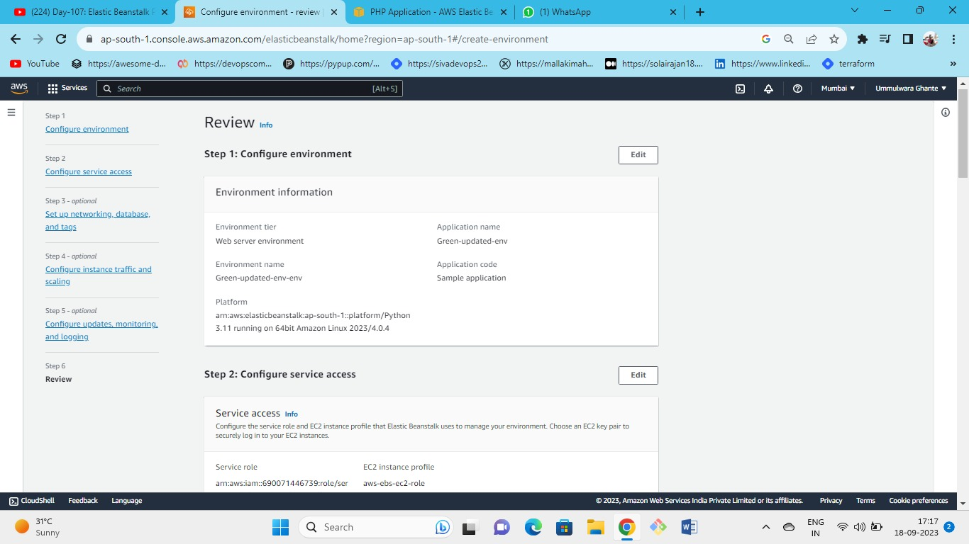

Review and launch the environment

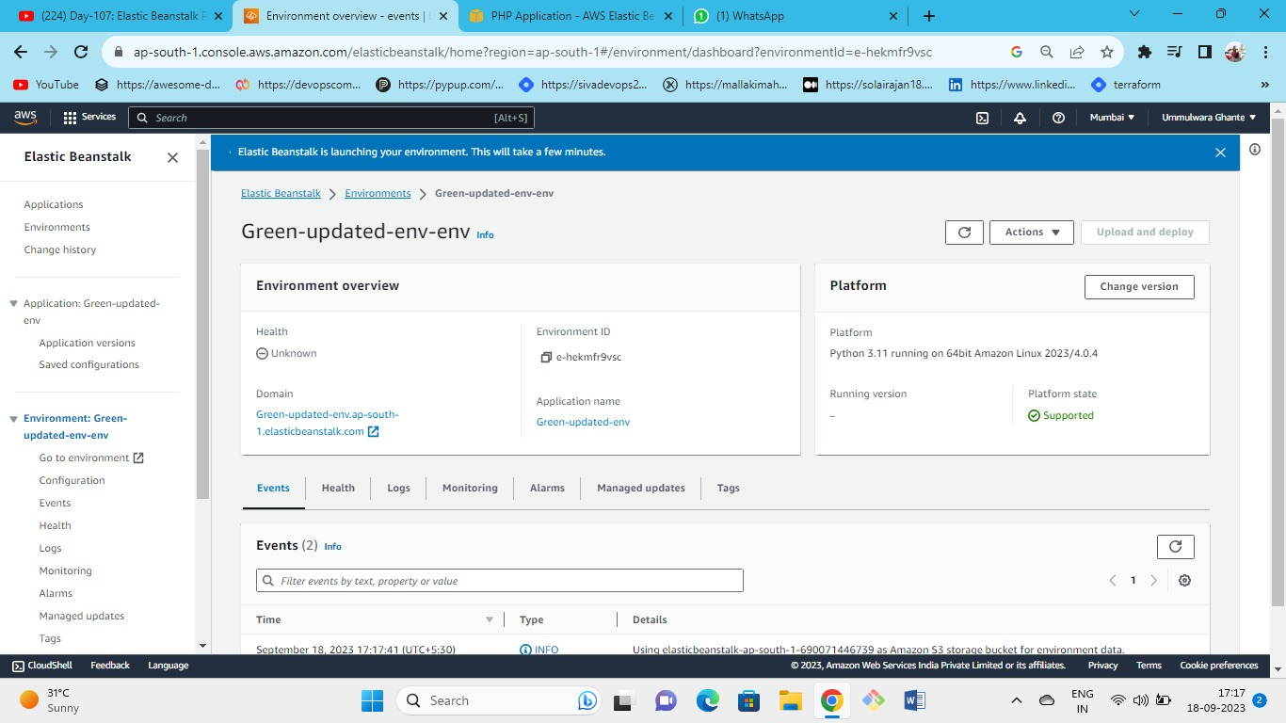

New environment being created

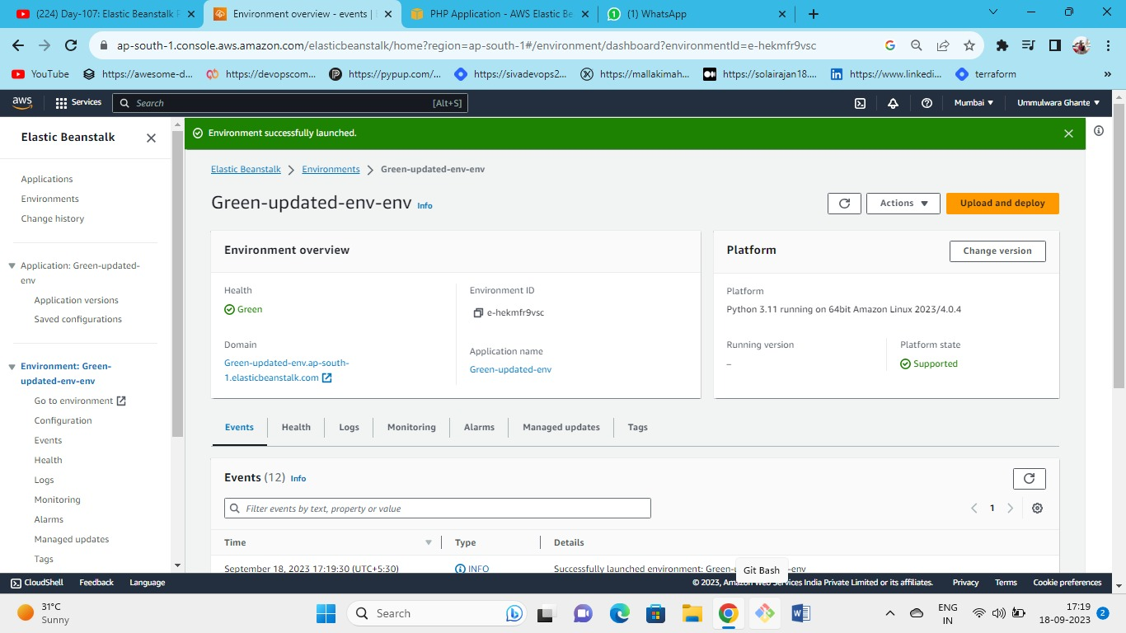

Our green environment successfully launched.

Click on the domain name of the green environment and you will see the sample application launched.

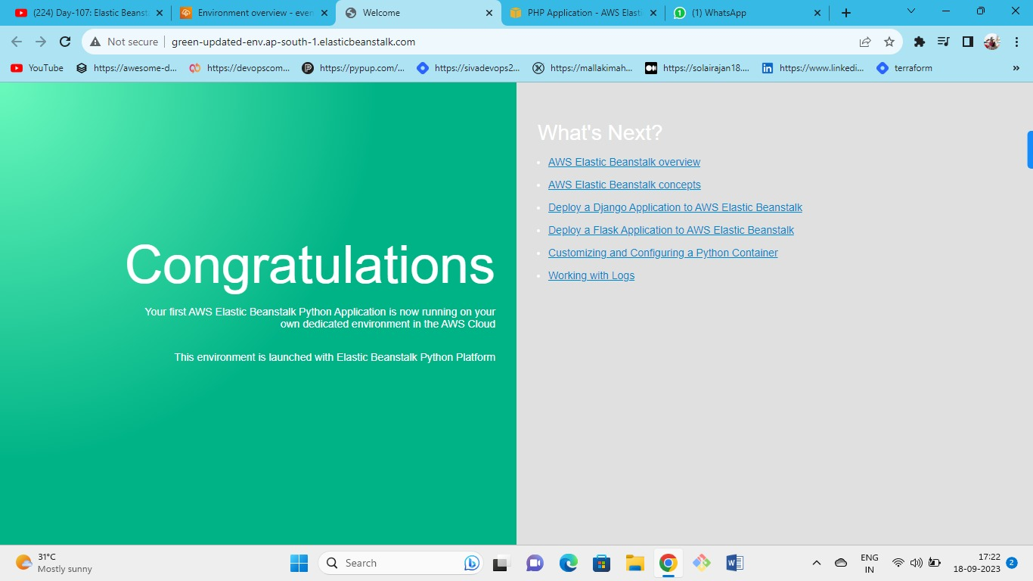

Launched python environment from sample application as we can see green environment URL is on the top.

**Now we can see the updated Python environment (i.e., green env) with the same blue-green environment URL.**

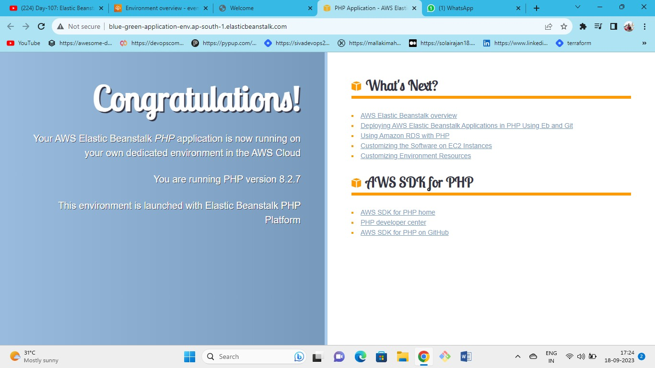**Now currently we have PHP environment by clicking on the blue-green env URL**

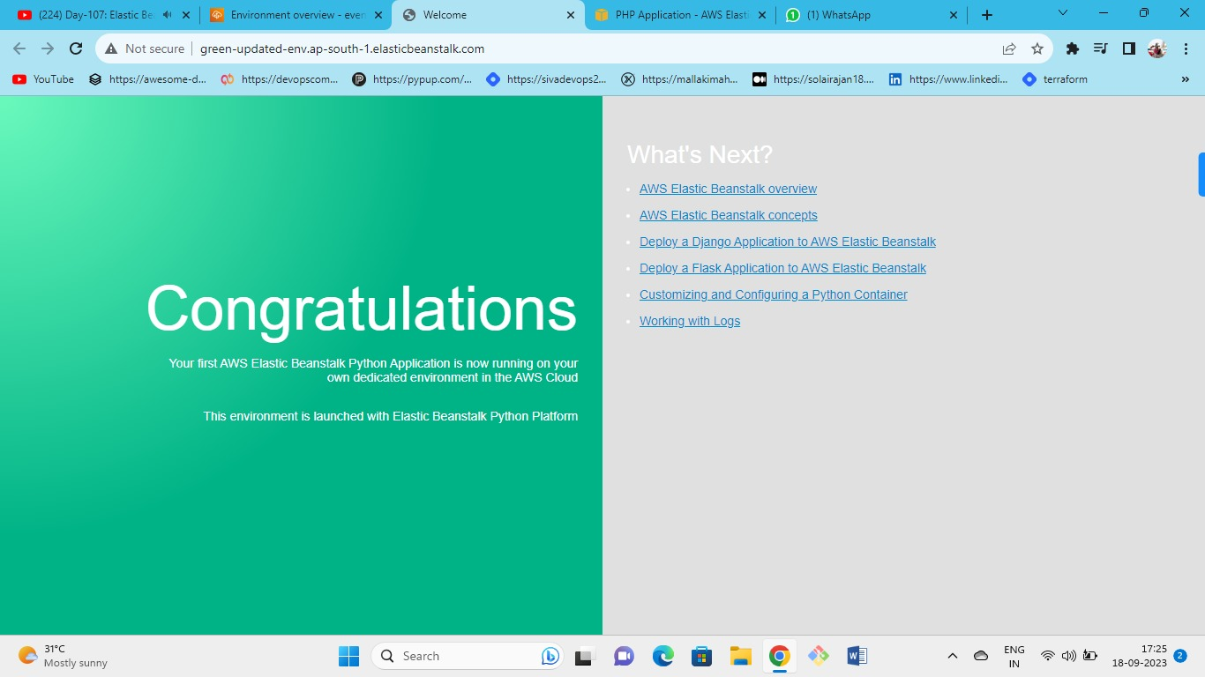

**Here now we have newly created python—green env as we can see from the URL**

**So if we don’t want downtime and also if we don’t want our actual URL to be changed and if we want to get the UPDATED application (i.e. in this case python) on our actual blue-green env URL then simply we can swap the URL’s.**

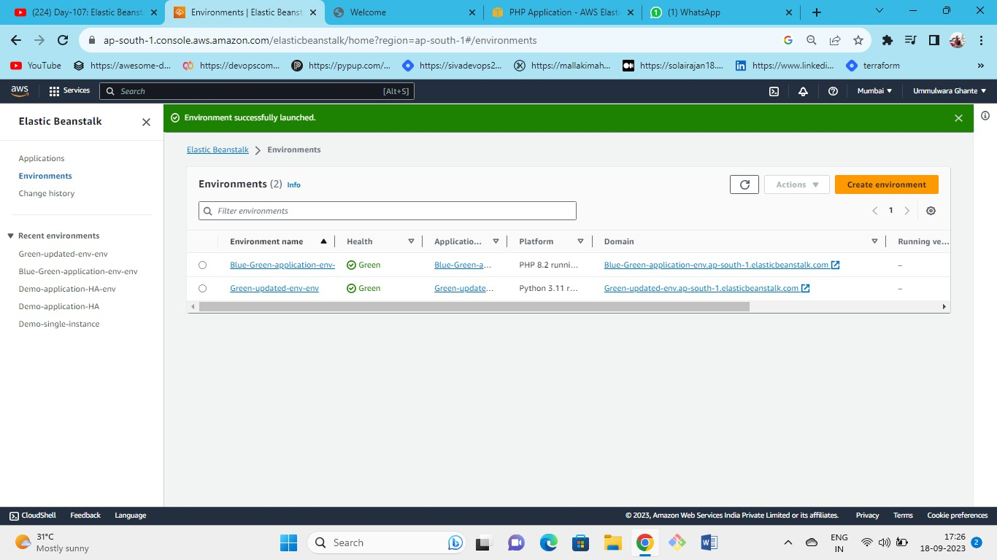



**To swap the application go to the Environments section**

**Once you swap the URL you can access the green-updated env URL from the blue-green-env URL.**

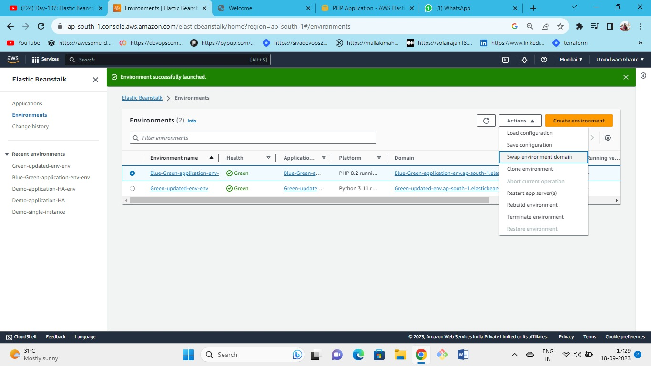

1. **To swap the env select the env whose URL needs to be swapped with the updated env URL.**
2. **Here it is blue-green env whose URL needs to be swapped with the updated green env.**
3. **After selecting to Actions tab and choosing the swap environment URL option.**

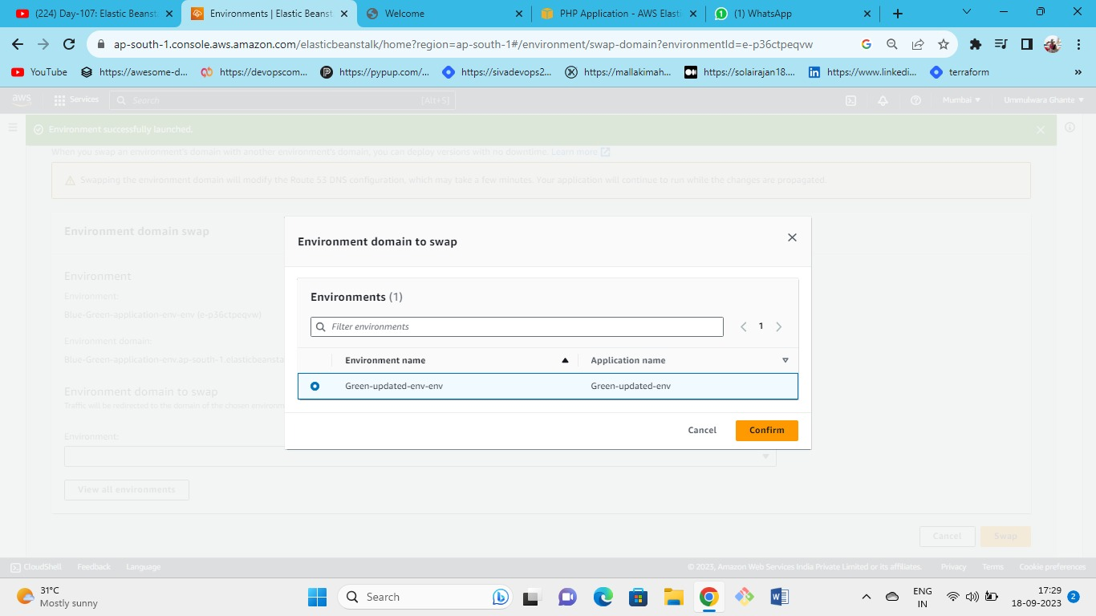

**select the updated environment URL which is to be swapped with the actual environment**

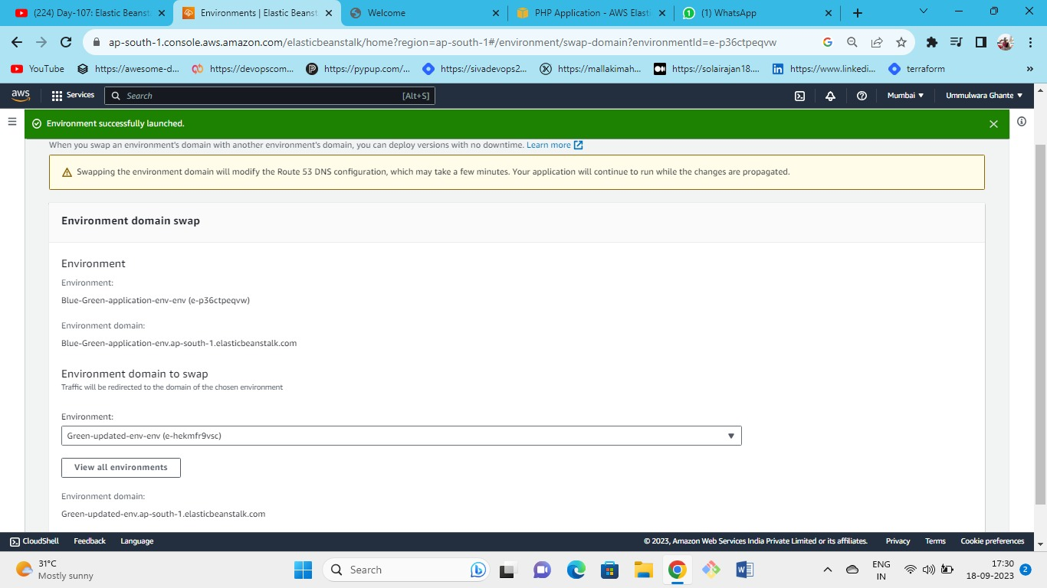



We have selected green env

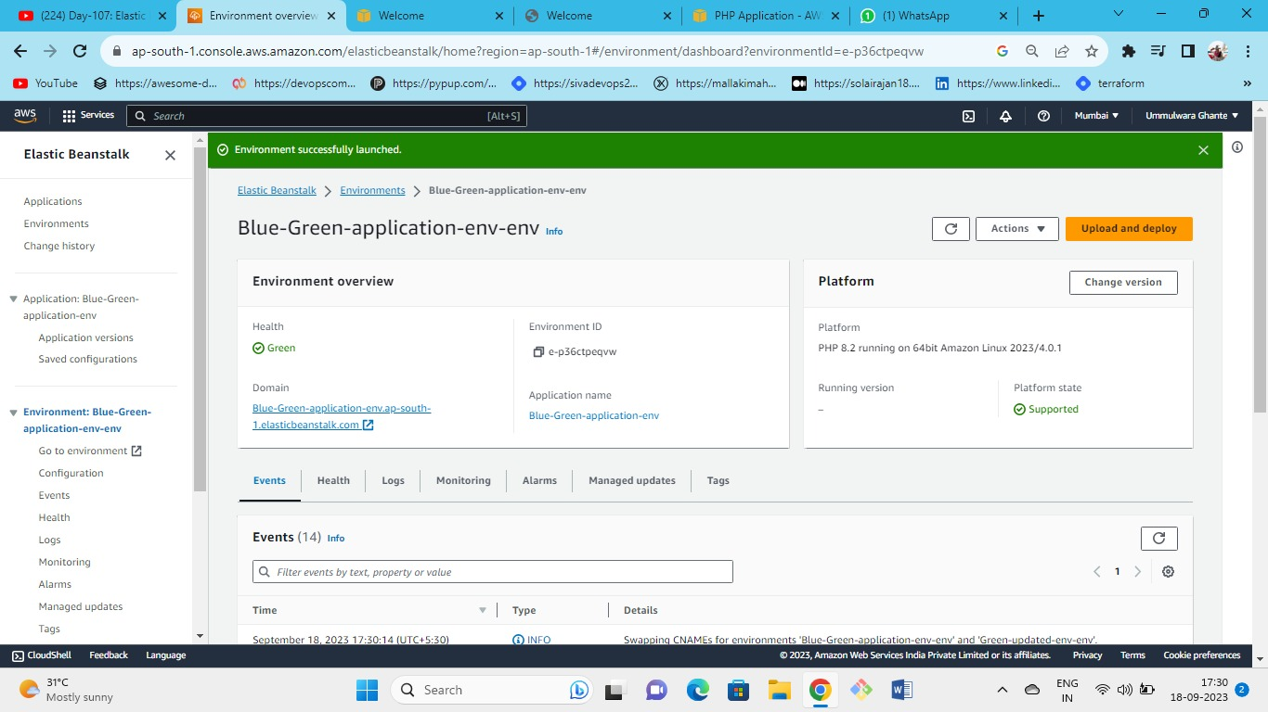

As you are on blue-green env but now with the blue-green env URL you can see the green-updated env URL.

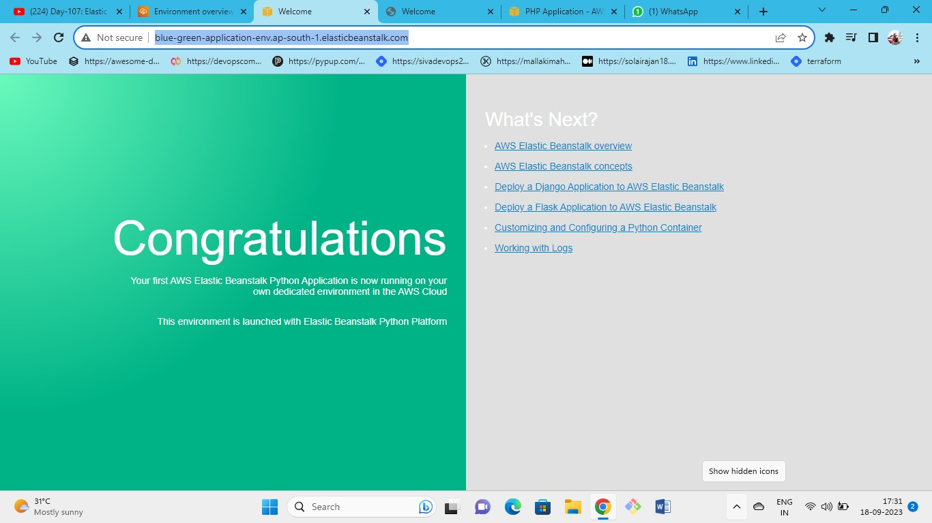

As we can see the URL is of blue-green env but we can experience the updated Python env using the same URL link (i.e., blue-green env).

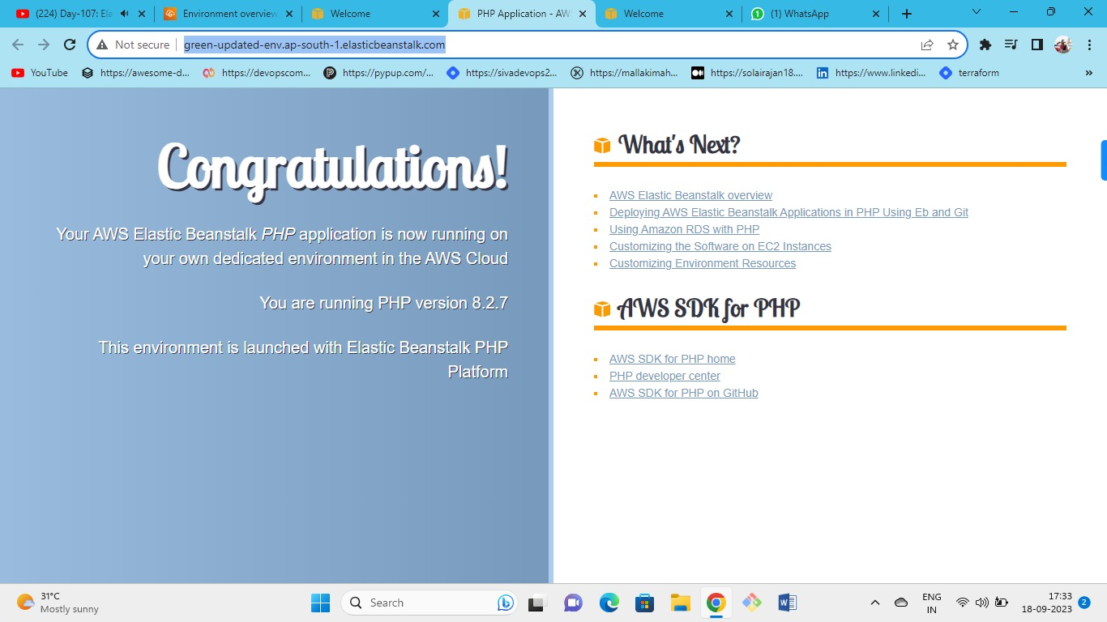

As we can see the URL is of the green env but we can experience the updated PHP env using the same URL link (i.e., green env).

As we can see by clicking on the green env URL we are getting our actual PHP application even though our platform is Python this is because we have swapped our env domains.

It is very useful for the real-time application.

Successfully launched Blue-Green Environment.